Querying Data
Distinct Values:
Alias (AS):

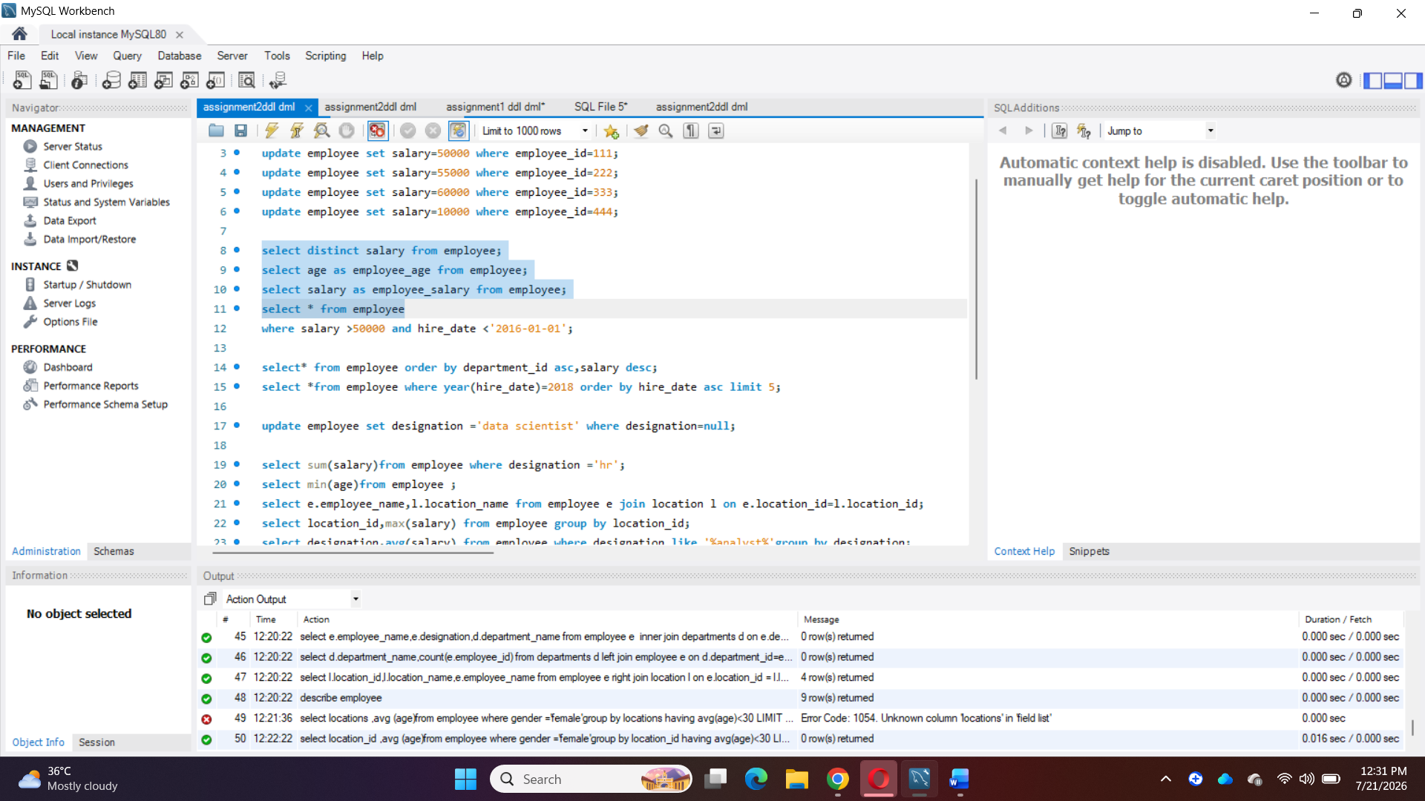
Where Clause & Operators:

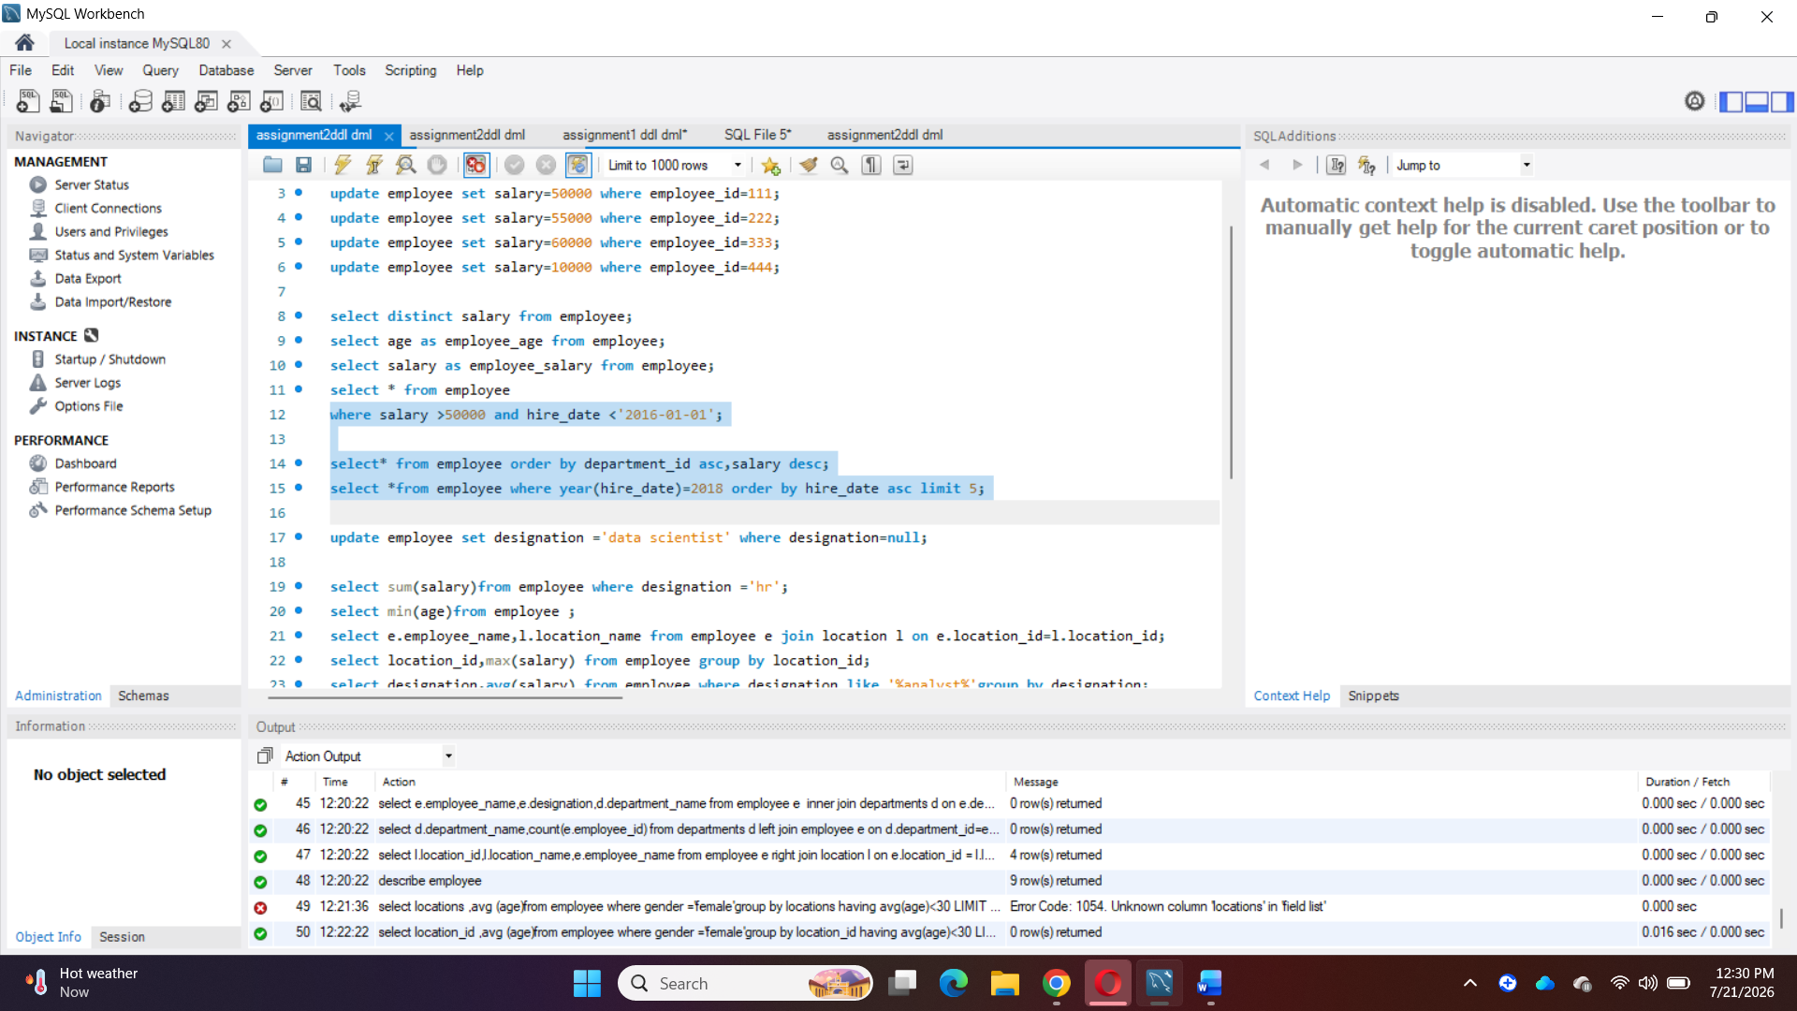

Sorting and Grouping Data:
LIMIT BY
AGGREGATE
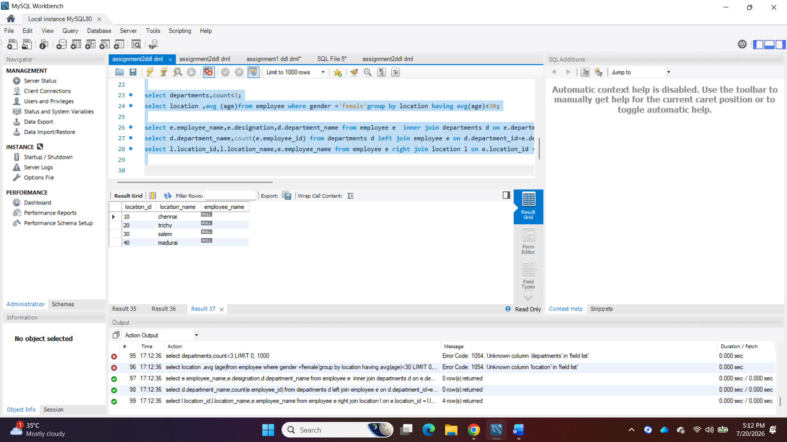

Group by, Having:

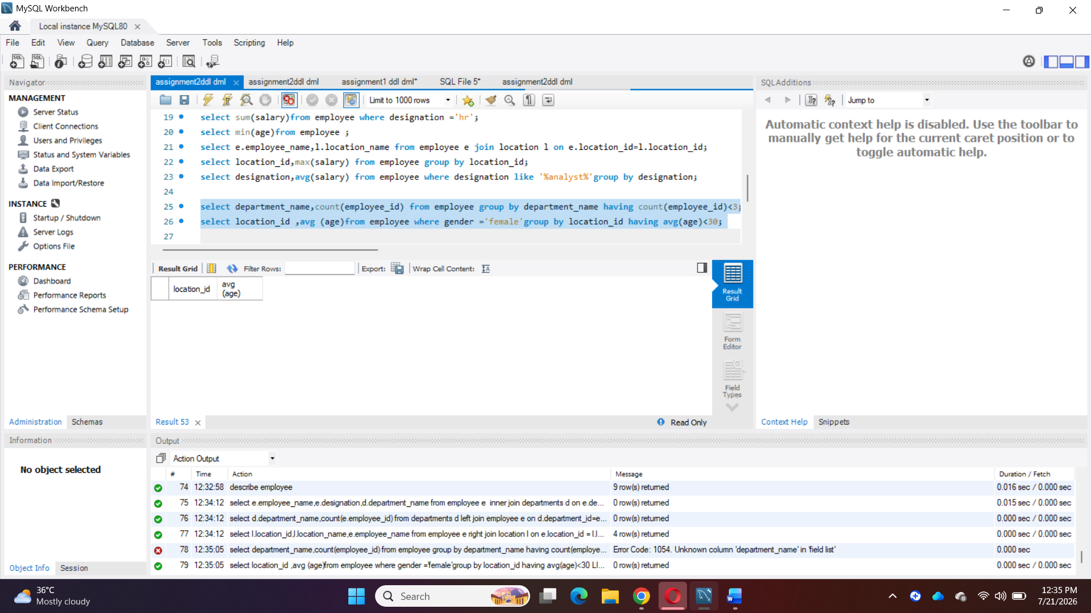

Joins
- Inner join
- Right join
- Left join


OUTPUT